

**YEAR: 7**

**2024**

**SUBJECT: Science**

**TEST: Transition 1**

**TIME: 45 minutes**

**QUESTIONS: 10 Multiple Choice (10 marks)**

**9 Short Answer (29 marks)**

**TOTAL MARKS: 39 marks**

**DO NOT WRITE ON OR MARK THIS PAPER**

**SECTION ONE—MULTIPLE CHOICE** (10 marks)

This section has **10** questions. Answer **all** questions on the separate Multiple-choice Answer Sheet provided.

1. This picture is a scientific diagram of a:

[This Photo](https://en.m.wikipedia.org/wiki/File:WikiJournal_of_Science_logo.svg) by Unknown Author is licensed under [CC BY-SA](https://creativecommons.org/licenses/by-sa/3.0/)

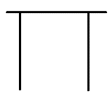

1. Tripod
2. Beaker
3. Test tube
4. Retort Stand
5. Which of the following is NOT the correct way to draw a scientific diagram?
6. Label equipment
7. Use ruler to draw lines
8. Minimal details with only an outline
9. Use a blue pen
10. Which is the correct way of writing the unit symbol for *kilogram*?
11. KG
12. Kg
13. kgs
14. 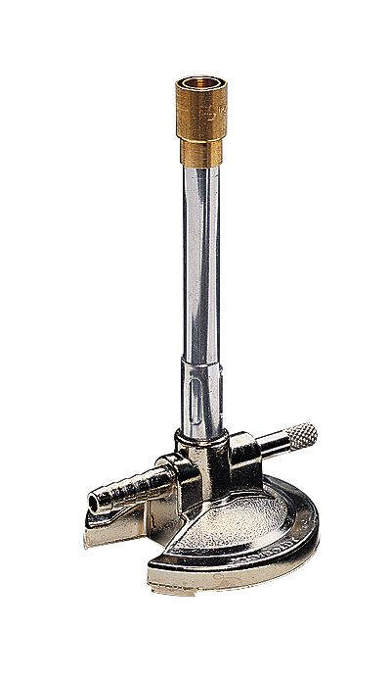kg
15. Which rule below would you NOT follow when using a Bunsen burner?
16. Long hair must be tied back
17. Wear protective clothing and safety glasses
18. Place the Bunsen burner directly onto the unprotected bench
19. Keep the gas tap closed when attaching the rubber hose from the Bunsen burner
20. 5) Which of the following is a quantitative observation?
21. The water was hot.
22. The water was clear.
23. The water was at a temperature of 34oC.
24. The water was colourless.

6. When heating a test tube, it should be:

a) Held with four fingers

b) Pointed away from yourself and other students

c) Heated over a tripod and gauze mat

d) Filled completely with the liquid

1. 7. A student uses a chemical that has the hazard symbol shown below.

Which of the following does NOT apply to this chemical?

a) Can be absorbed by the skin

b) Keep away from flames

c) Easily set on fire

d) Flammable materials

8. Which of the options below is the **most accurate** measurement as shown in the diagram of a

measuring cylinder?

a) 21.3 mL

b) 21.4 mL

c) 21.5 mL

d) 22 mL

9. Which of the following is an important part of safety in the lab:

a) Wearing safety glasses while mixing or heating substances

b) Wearing a lab coat for practical work

c) Wearing solid shoes to completely cover your feet

d) All of the above

10. If it is safe to smell a chemical in a science laboratory, you should

a) Smell it for as long as you can

b) Take a deep breath

c) Waft the odour toward you

d) Use a fan

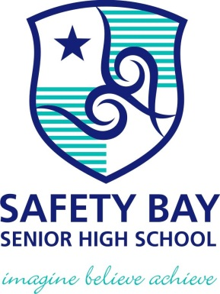

**SEMESTER ONE 2024**

**Transition 1 Science Test:**

**ANSWER BOOKLET**

**NAME:**

**FORM:** **DATE:**

Multiple Choice Short Answer Total

**/29**

**/10**

**/39**

**SECTION ONE:** Multiple choice answers

Cross (X) through the correct answer.

|  |  |  |  |  |
| --- | --- | --- | --- | --- |
| **1** | a | b | c | d |
| **2** | a | b | c | d |
| **3** | a | b | c | d |
| **4** | a | b | c | d |
| **5** | a | b | c | d |
| **6** | a | b | c | d |
| **7** | a | b | c | d |
| **8** | a | b | c | d |
| **9** | a | b | c | d |
| **10** | a | b | c | d |

|  |  |
| --- | --- |
| **I CAN STATEMENT** | **QUESTIONS** |
| **MUST**  Identify questions that can be investigated, plan and conduct fair experiments showing logical steps in method and identify how variables will be changed and measured.  Comprehensively communicate your ideas, methods and findings in detail using scientific language and appropriate representations. | MC: 1, 2, 4, 5, 8, 9 & 10  S: 1, 2, 3, 4, 5, 8 |
| **SHOULD**  Identify questions that can be investigated, plan and conduct fair experiments showing logical steps in method and identifying variables to be changed and measured.  Communicate your ideas, methods and findings in detail using scientific language and appropriate representations. | MC: 3 & 7  SA 4, 5, 6 ,8 |
| **COULD**  Identify questions that can be investigated, plan and conduct fair experiments, identifying variables to be changed and measured.  Communicate your ideas, methods and findings using some scientific language and appropriate representations. | MC: 6   S: 1 & 3, 8 |

**SECTION TWO: Short Answer (29 marks)**

Answer the questions in the spaces provided.

1. Match the following job descriptions to the branch of Science (6 marks)

Psychology Dave is looking through his telescope at the stars.

Chemistry Nasir is investigating what food wombats eat.

Geology Steve is studying why children want to play with toys while old people do not.

Biology Patrice is testing what substances are burnt by acids.

Astonomy Manni is investigating how to make electrical devices use less energy.

Physics Vicki is working out what pollution is doing to the local creek.

Ecology Jen is studying different rock types.

1. 2. The following statements were written as part of a prac report. **Identify** which statement is the

Purpose, Materials, Method and Conclusion. (4 marks)

1. **Statement 1**
2. 100 mL of water was put in a large beaker. 100 mL of cooking oil was slowly dripped onto its surface.
3. **Statement 2**
4. cooking oil, water, large beaker
5. **Statement 3**
6. The oil formed a layer on top of the water.
7. **Statement 4**
8. To test if oil floats on water.

3. Sabina drew the diagram below as her scientific diagram. However, you know that she is mistaken.

1. Redraw the diagram below using a simpler line form (suitable for inclusion in a report) and label each part. (4 marks)

1. Name the piece of equipment that is missing from the photo above to ensure Sabina’s experiment is carried out safely.

________________________________ (1 mark)

1. Name one PPE (personal protective equipment) Sabina needs to wear to keep herself safe?

(1 mark)

________________________________

4. Next to each piece of equipment, write the measurement. Remember to include **correct units**.

(3 marks)

a) The measurement on the ruler is: ______________unit ______.

1. 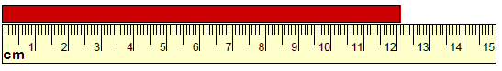

b) The temperature shown on the thermometer is __________unit _____.

c) The volume of liquid in the cylinder is ___________ unit____.

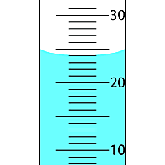

5. Place the steps for lighting a Bunsen burner in the correct order. The first step is already done for you. (2 marks)

|  |  |
| --- | --- |
| **Step** | **Correct order** |
| Connect the rubber hosing firmly to the gas tap |  |
| Close the air hole by turning the collar |  |
| Place the Bunsen burner on the heating mat | 1 |
| Open the gas tap fully |  |
| Light a match and place it above the barrel, with your hand below the flame |  |

6. Define the following terms: (3 marks)

Observe

_________________________________________________________________________________  
  
_________________________________________________________________________________

Experiment

_________________________________________________________________________________  
  
_________________________________________________________________________________

Parallax error

_________________________________________________________________________________  
  
_________________________________________________________________________________

**7.**

equipment next to the picture. (8 marks)

|  |  |  |  |
| --- | --- | --- | --- |
| **Name** | **Equipment** | **Name** | **Equipment** |
|  | Image result for test tube |  | Retort Stands, 60cm Stand, 20 x 13cm Base |
|  | A picture containing furniture, stool, seat, table  Description automatically generated  [This Photo](https://en.wikibooks.org/wiki/Science:_A_Field_Of_Wonder/About_The_Laboratory) by Unknown Author is licensed under [CC BY-SA](https://creativecommons.org/licenses/by-sa/3.0/) |  | Image result for conical flask |
|  | Image result for tongs metal |  | Test Tube Rack 22-25 mm Diameter - IC-30400118 |
|  | Image result for gauze mat |  | Image result for funnel lab |

8) Hot Drinks Cooling Investigation

**Questioning and Predicting (4 marks)**

State the variables for this investigation:

What will I change ( Independent variable)

_________________________________________________________________________________

What will I measure (Dependent variable)

________________________________________________________________________________

Write the question to be investigated

_______________________________________________________________________________

Write a prediction of what you think will happen

_______________________________________________________________________________

**Planning and Conducting (4 marks)**

Discuss the possible safety risks in this investigation and suggest how they can be managed

_______________________________________________________________________________

_______________________________________________________________________________

_______________________________________________________________________________

_______________________________________________________________________________

_______________________________________________________________________________

**Evaluating (2 marks)**

Describe how the investigation could be improved

_________________________________________________________________________________

_________________________________________________________________________________

_________________________________________________________________________________

_________________________________________________________________________________

**END OF TEST**